Poor Report Patterns
(This is not an exhaustive list of everything, just some of the more commonly seen issues in past semesters)

Submitting a zip file but forgetting to submit a report at the top level.
Bad:
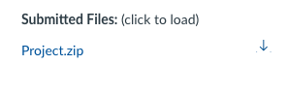
Good:
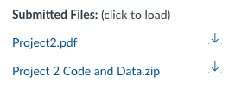

Missing Indentation on paragraphs:
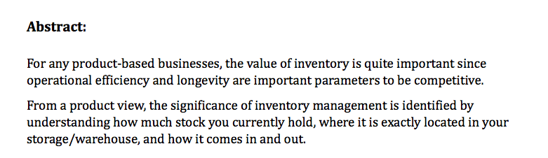

Captions missing on images/charts:
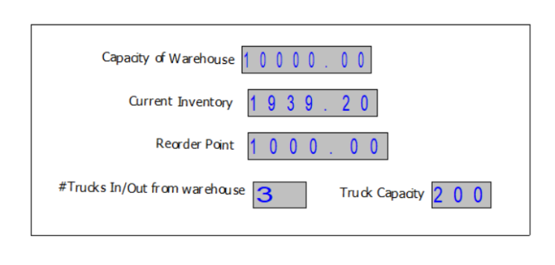

Charts that are hard to parse due to missing y labels, cutoff x-labels, and being unnecessarily large.
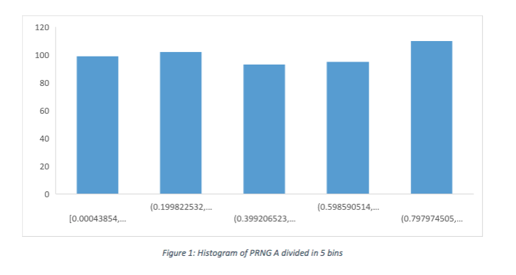

Figures having labels and axes labels too small to read:
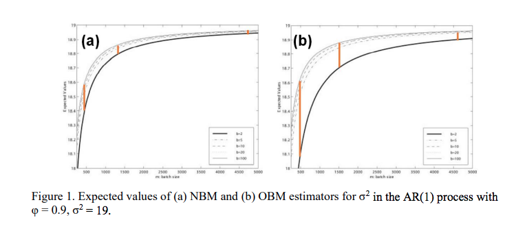

Figures/Charts taking up unnecessarily large amounts of space and having far too much useless whitespace (shown are 4 consecutive pages of a report, in zoomed out view):
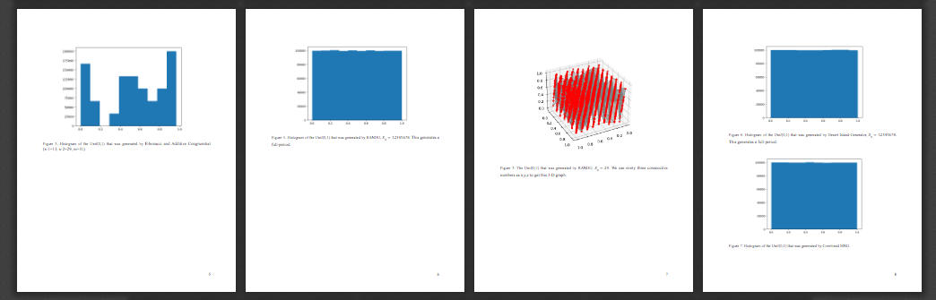

Ugly screenshots of code in report:
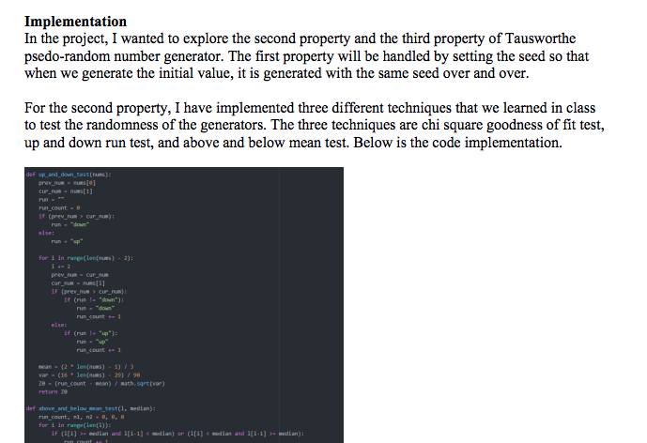

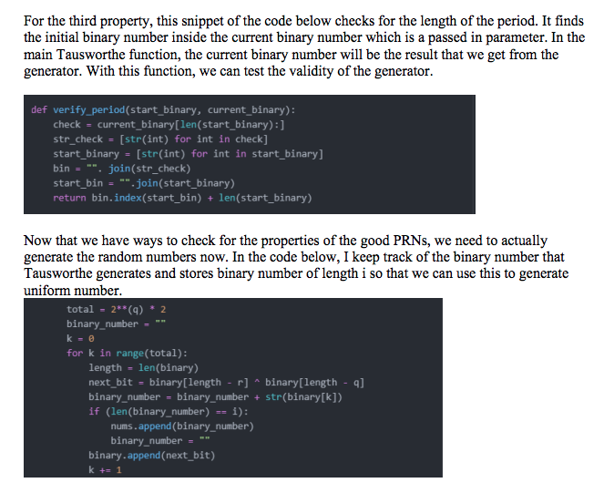

Excel screenshots in the paper
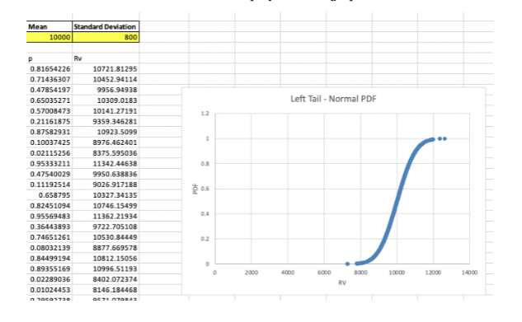

Hard to read Arena diagrams in the paper
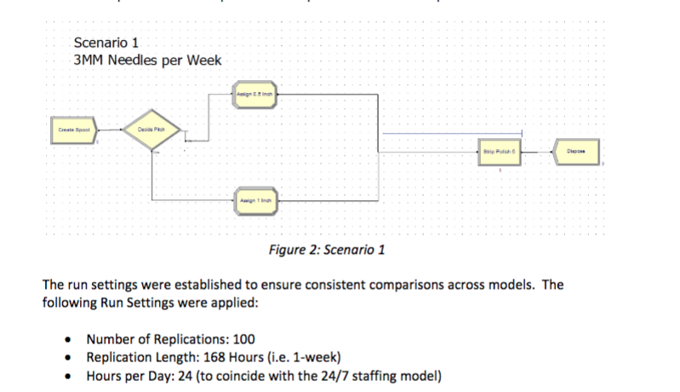

Poor editing of paper:
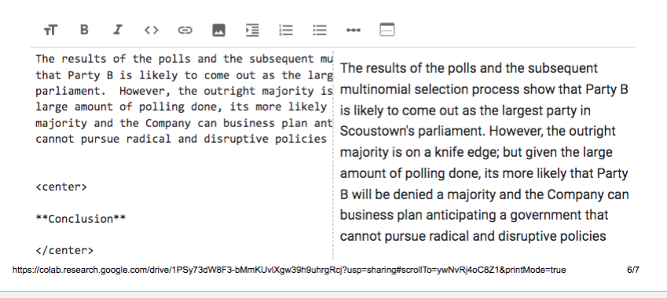

Paper missing organizational section headings like Abstract, Background, etc… (also this paper is far too short and low effort)
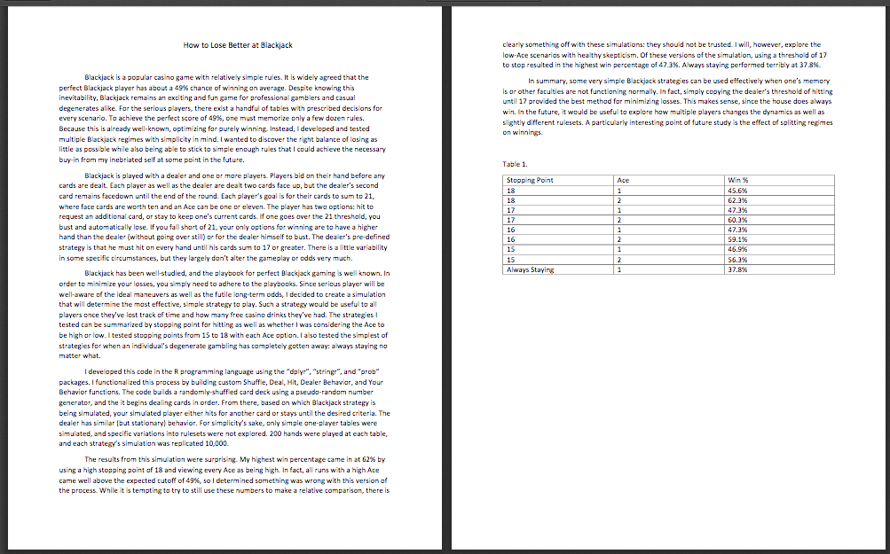

Inconsistent line spacing:
